1. Using DOM Navigation Create a TODO APP, it will show add new elements and delete

Elements

Todolist.html

<!DOCTYPE html>

<html lang="en">

  <head>

    <meta charset="UTF-8" />

    <meta http-equiv="X-UA-Compatible" content="IE=edge" />

    <meta name="viewport" content="width=device-width, initial-scale=1.0" />

    <title>Todo List</title>

    <link

      href="https://cdn.jsdelivr.net/npm/bootstrap@5.3.0-alpha3/dist/css/bootstrap.min.css"

      rel="stylesheet"

      integrity="sha384-KK94CHFLLe+nY2dmCWGMq91rCGa5gtU4mk92HdvYe+M/SXH301p5ILy+dN9+nJOZ"

      crossorigin="anonymous"

    />

    <script src="todolist.js"></script>

  </head>

  <body

    style="

      border: 1px solid black;

      background-color: rgba(245, 220, 109, 0.507);

    "

  >

    <div style="text-align: center; border: 1px solid black; height: 100vh">

      <h1 style="text-align: center">ToDo List</h1>

      <input

        style="margin-bottom: 15px; width: 500px; margin-left: 450px"

        class="form-control"

        type="text"

        id="inp"

        placeholder="Enter element"

      />

      <input

        style="margin-bottom: 10px"

        class="btn btn-secondary mb-3"

        type="button"

        value="Add element"

        onclick="addElement()"

      />

      <div id="parent"></div>

    </div>

  </body>

</html>

Todolist.js

function addElement() {

    let inptag = document.getElementById('parent')

    let currentval = inptag.innerHTML;

    let msgtag=document.getElementById('inp')

    let elemtag=msgtag.value;

    let newval=`<div><div style="display: flex; justify-content: space-between; padding: 5px; margin: 10px">

        ${elemtag}

        <input type="button" value="Clear" onclick="clr(this)" />

      </div>

      <hr />

      </div>`

    inptag.innerHTML = currentval + newval;

    msgtag.value = ' ';

}

function clr(p1) {

    p1.parentElement.parentElement.remove();

}

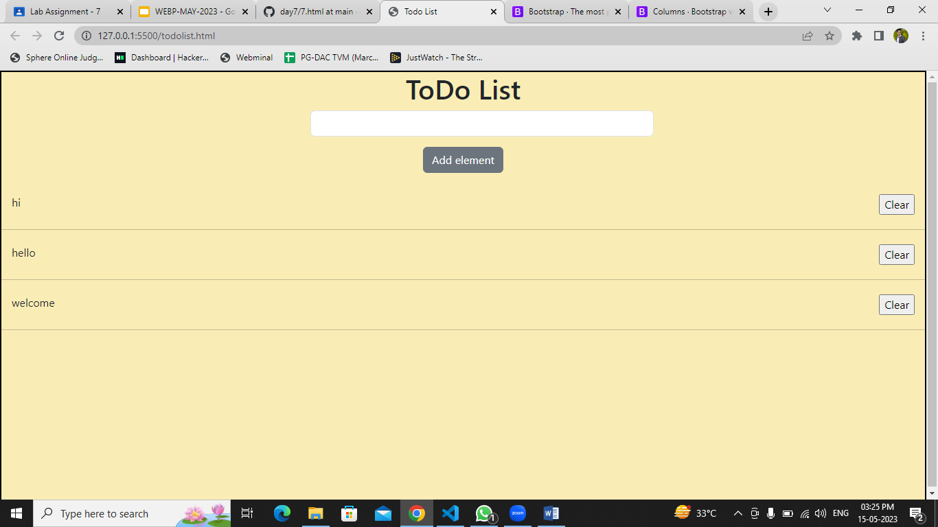

2. Create a static website using Bootstrap layout with Navbar,rows ,cols etc... and add to

try different features like accordion ,carrousal etc...